

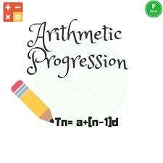

Module-1/5

LET US UNDERSTAND
WHAT IS AN ARITHMETIC PROGRESSION FIRST.
LET ME GIVE SOME EXAMPLES AND SOME COUNTER EXAMPLES. OBSERVE THE SERIES CAREFULLY.

APs

- 2,4,6,8,………
- -2,-3,-4,-5……
- 10,9,8,7,6,……..
- 5,10,15,20,……..
NOT APs
*2,3,2,3,2,3,……
*-2,-3,-5,-8,-12,…
*1,2,3,5,8,…….
*1,2,4,16,32,…..

IN THE FIRST COLUMN, WE SEE THAT THE SEQUENCE PROGRESSES IN A PARTICULAR
PATTERN .
IN THE SECOND COLUMN WE DON’T SEE THE SAME PATTERN.

IN THE FIRST COLUMN, WE
OBSERVE THAT THE DIFFERENCE BETWEEN THE CONSECUTIVE TERMS IS SAME/COMMON.
THIS IS KNOWN AS THE COMMON DIFFERENCE OF THE
ARITHMETIC PROGRESSION.

CAN YOU TELL ME IF
5,5,5,5,……..
IS AN ARITHMETIC PROGRESSION
OR NOT???
YES, IT IS!!!!!!!

BECAUSE THE DIFFERENCE BETWEEN THE CONSECUTIVE TERMS
IS A CONSTANT “0”
LET US FORM AN AP WITH

THE FIRST TERM 3 AND THE COMMON DIFFERENCE 4.
first term=3 second term=3+4=7
third term=7+4=11 HENCE OUR AP IS
3,7,11,15,19,……….
LET US DERIVE A

FORMULA FOR THE Nth TERM OF AN AP WITH THE FIRST TERM AS
‘a’
AND THE COMMON DIFFERENCE ‘d’
THE FIRST TERM 𝑎₁ =a

𝑎₂ = a+d=a+(2-1)d
𝑎3=a+d+d=a+2d=a+(3-1)d
𝑎4=a+2d+d=a+3d=a+(4-1)d similarly,
𝑎𝑛=a +(n-1)d

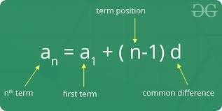
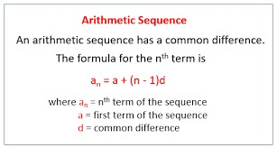

NOW,LET’S FIND OUT THE
100TH TERM OF AN AP WHOSE FIRST TERM IS -24 AND THE COMMON DIFFERENCE IS 4.
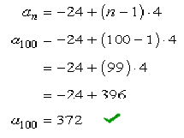

LET US DO A FEW SUMS
OF OUR EXERCISE 5.1 OF THE CHAPTER ARITHMETIC PROGRESSION.

THE TAXI FARE AFTER EACH KM WHEN THE FARE IS Rs.15 FOR THE FIRST KM AND Rs.8 FOR EACH ADDITIONAL KM. WILL IT FORM AN AP?
YES!!!!!!
HERE, THE FIRST TERM IS 15 AND THE COMMON DIFFERENCE IS 8.
THE AMOUNT OF AIR

PRESENT
IN A CYLINDER WHEN A VACUUM PUMP REMOVES 1/4TH OF THE
AIR REMAINING IN THE CYLINDER AT A TIME.
LET US A CYLINDER HAS 16 CUBIC UNITS OF AIR.

REMOVING 1/4TH MEANS REMOVING 4 CUBIC UNITS OF AIR. REMAINING IS 12 CUBIC UNITS. REMOVING 1/4TH AGAIN MEANS
3 CUBIC UNITS.
IS THE DIFFERENCE COMMON?
LOOK AT THE AP

2, 8, 18, 32,…….
IS IT AN AP?
THIS CAN ALSO BE WRITTEN AS
√2,2√2,3√2,4√2,…….
THE FIRST TERM IS
2
AND THE DIFFERENCE IS ALSO 2.
HENCE, IT IS AN AP.

1²,3²,5²,7²,…… CAN BE REWRITTEN AS
1,9,25,49,…….
CHECK IF IT IS AN AP?

THANK YOU!!!!!!

